**# Instagram photo downloader command**

#Instagram Photo Downloader

instaloader profile username

instaloader –help

instaloader --no-videos --comments --geotags --no-metadata-json --no-compress-json profile username

instaloader --no-videos --comments --geotags --no-metadata-json --no-compress-json –login username profile ritesh.ai

instaloader --no-videos --comments --geotags --no-metadata-json --no-compress-json –loginusername-password password profile ritesh.ai

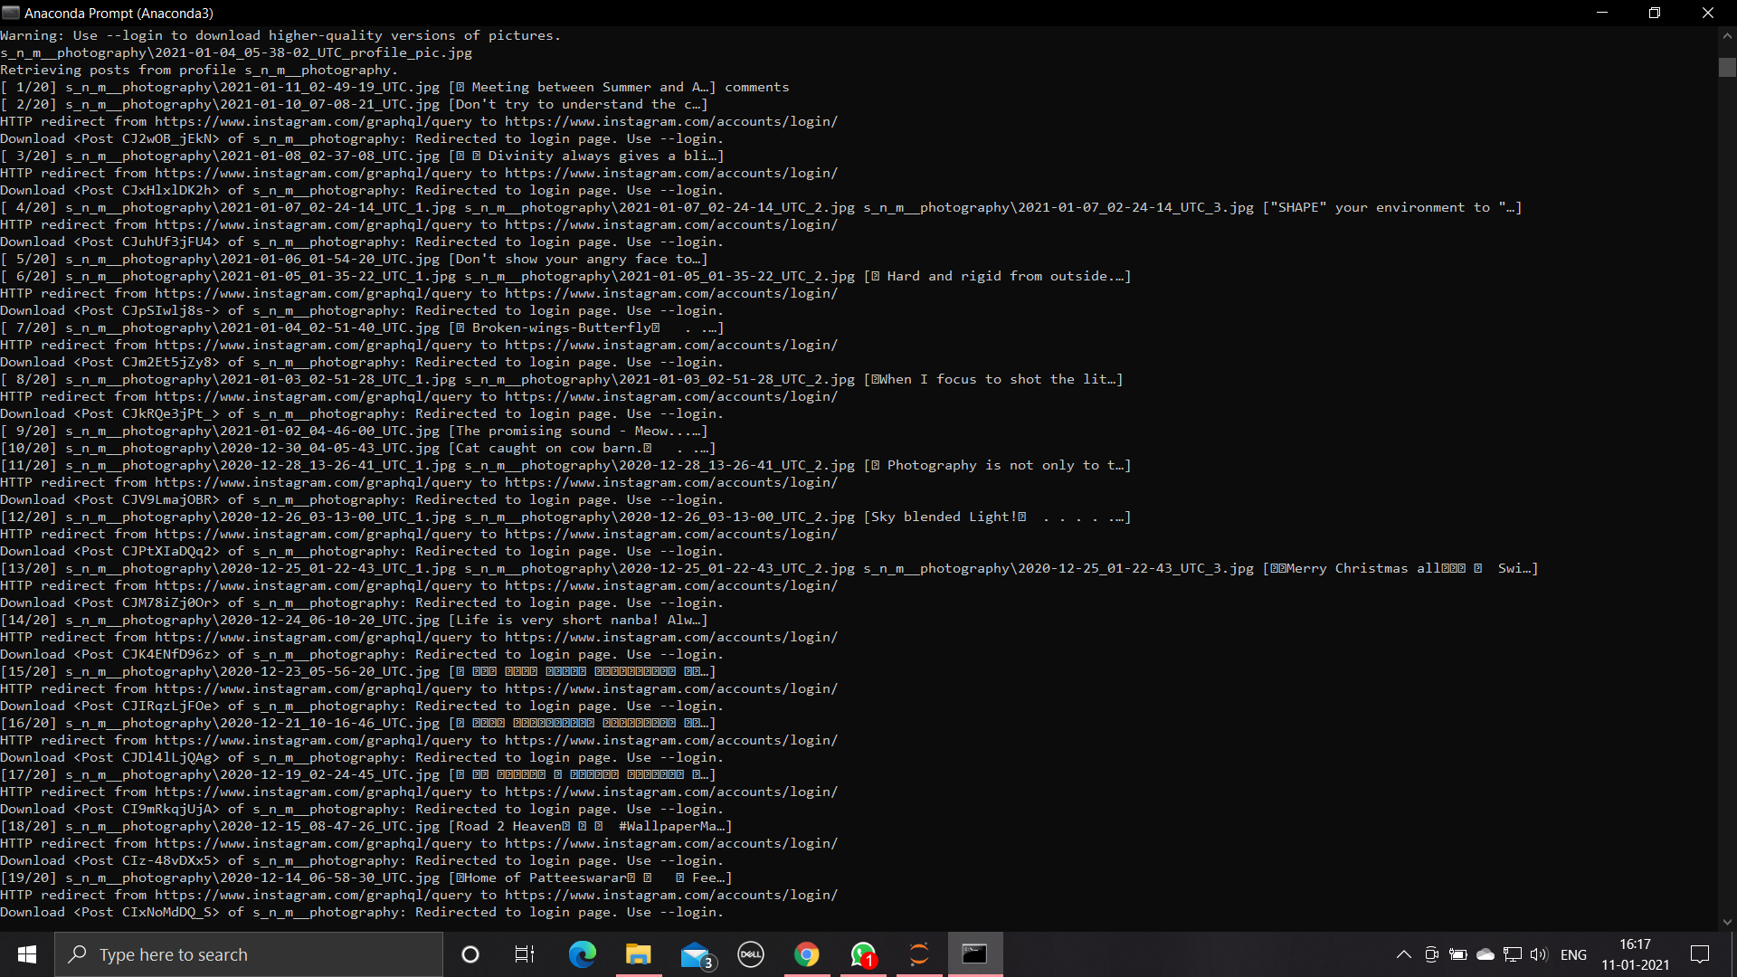

SCREEN SHOT